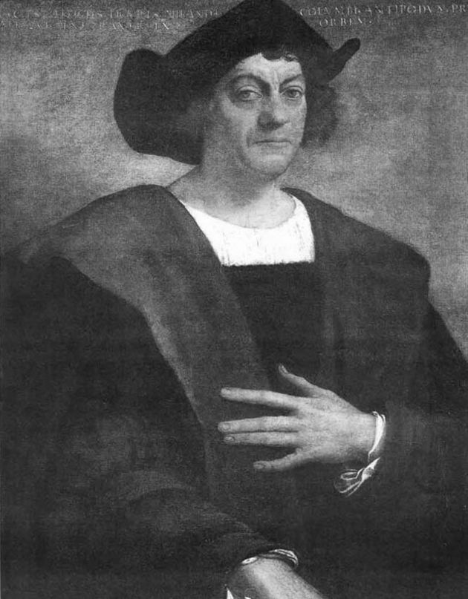
Explorers Unit: Blabberize Project

After Christopher Columbus discovered the New World in 1492, numerous explorers from different parts of the world wanted to take part in the action. While they all had a sense of adventure, the explorers often had different goals and experiences. In this project, your group will be assigned an explorer who has left a lasting impact in the Americas.

Hernando Cortes Francisco Pizarro Juan Ponce de Leon

Hernando de Soto Vasco Nunez de Balboa Amerigo Vespucci

With your group, you will research the life and accomplishments of your explorer to create a Blabberized project. In the project, you will give a FIRST-PERSON interview as if you were the explorer himself. From the perspective of your explorer, you will answer the following questions:

1. When were you born?
2. When did you die?
3. What country are you from?
4. What are the names of your parents?
5. What types of jobs have you had?
6. Where did you explore?
7. How did you get there?
8. What did you discover?
9. How was your experience?
10. What are some of your accomplishments?

Once you have finished researching your explorer, you will need to write out a script of what you are going to say. Every person should have a speaking part in the final project. After your script is written answering all 10 questions, go to Blabberize.com to put it all together.

*E-mail the link to your project to Ms. Johnson-shiquita.johnson@dpsnc.net

Below is a list of websites that may help you gather some information on your explorer:

These are some websites you can use that have information about your explorers:

http://library.thinkquest.org/J002678F/

http://www.history.com/topics/exploration-of-north-america

http://www.42explore2.com/explorers2.htm

http://library.thinkquest.org/4034/hall_of_fame.html

http://cybersleuth-kids.com/sleuth/History/Explorers/

http://www.enchantedlearning.com/explorers/america.shtml

http://www.ducksters.com/biography/explorers/

http://mrnussbaum.com/explorers/explorerprofiles

